Time Thieves
You must inspect your traffic capture to answer the following questions:
- What is the domain name of the users' custom site? Frank-n-ted.com
- What is the IP address of the Domain Controller (DC) of the AD network? DC = 10.6.12.12 AD network = 10.6.12.157
- What is the name of the malware downloaded to the 10.6.12.203 machine? June11.dll
  - Once you have found the file, export it to your Kali machine's desktop.
- Upload the file to VirusTotal.com.
- What kind of malware is this classified as? Trojan

Vulnerable Windows Machine
- Find the following information about the infected Windows machine:
  - Host name: ROTTERDAM-PC
  - IP address: 172.16.4.205
  - MAC address: 00:59:07:b0:63:a4
- What is the username of the Windows user whose computer is infected? Matthijs devries
- What are the IP addresses used in the actual infection traffic? 31.7.62.214
- As a bonus, retrieve the desktop background of the Windows host.
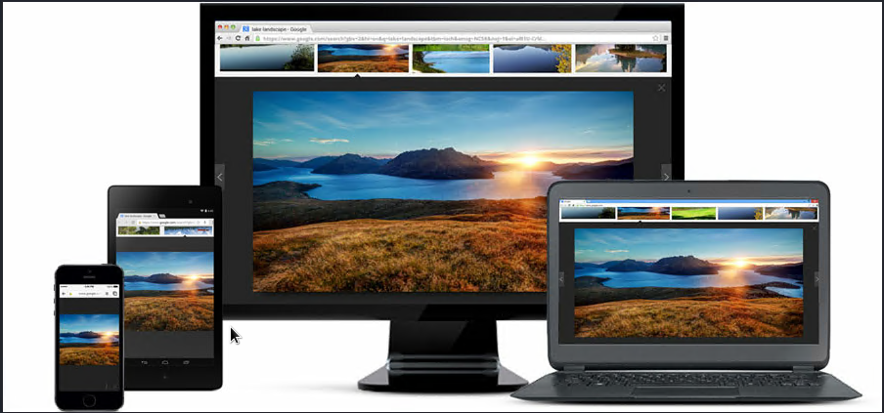
?????

Illegal Downloads
- Find the following information about the machine with IP address 10.0.0.201:
  - MAC address: 00:16:17:18:66:c8
  - Windows username: elmer blanco
  - OS version: Windows NT 10.0
- Which torrent file did the user download? Betty_Boop_Rhythm_on_the_Reservation.avi.torrent

